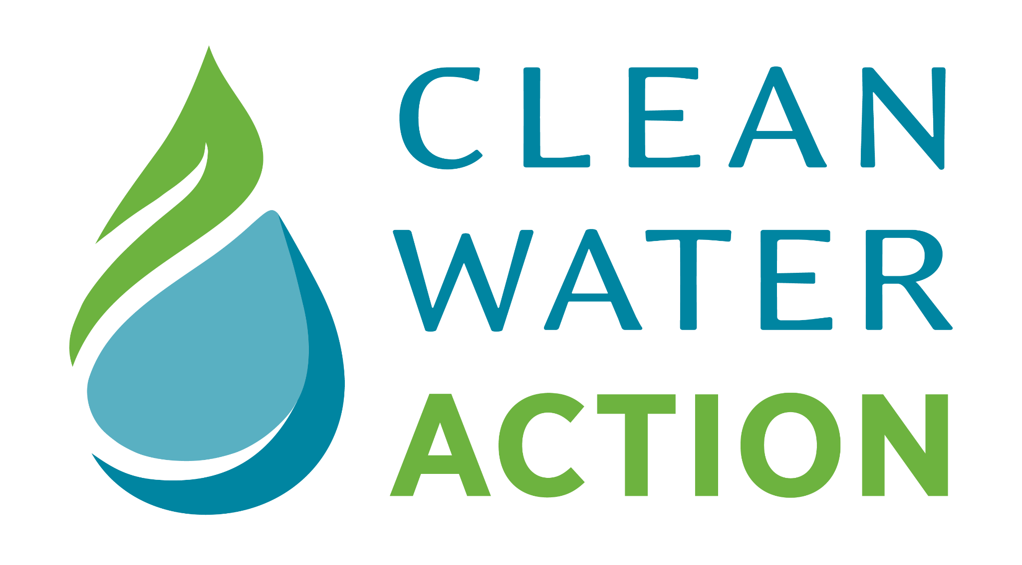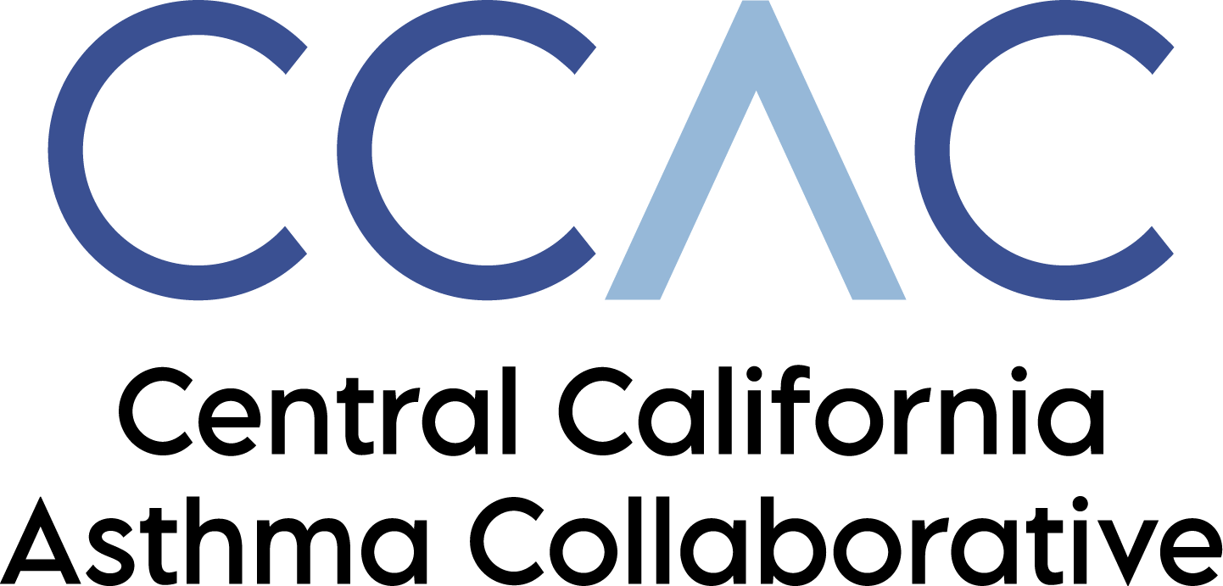 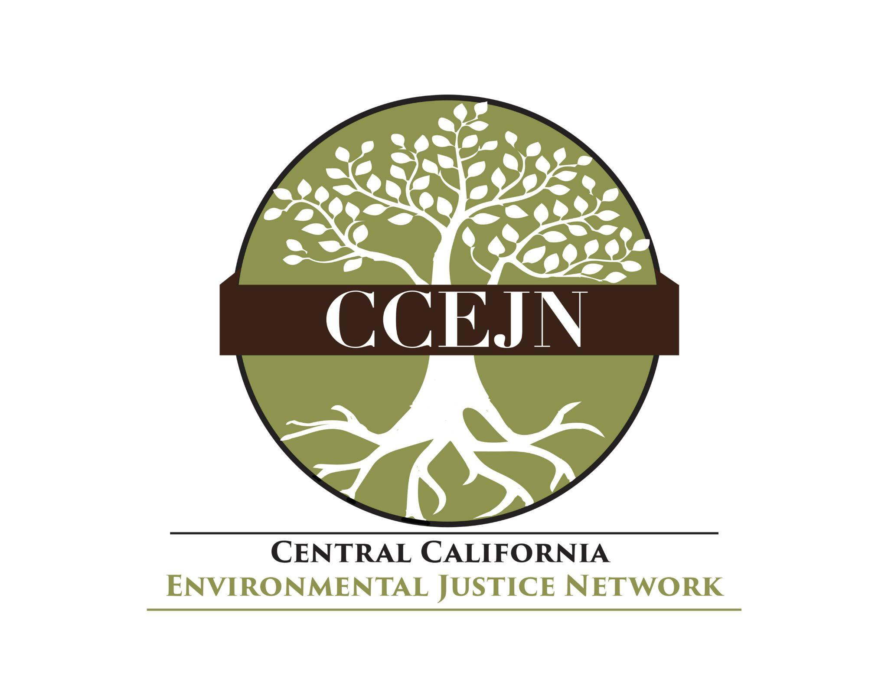 CWAM
July 29, 2026
Dr. Rima Woods, Chief
Air Toxicology and Risk Assessment Section
California Office of Environmental Health Hazard Assessment
1021 O Street, Suite 3230
Sacramento, CA 95814
Transmitted via email at Rima.Woods@oehha.ca.gov
Re: Acrolein Inhalation Unit Risk Factor (IUR)
Dear Dr. Woods:
The undersigned organizations support the methodology and findings used to set the new Inhalation Unit Risk Factor (IUR) for acrolein at 7.9 × 10⁻⁴ (μ g/μ m³), and we thank the Office of Environmental Health Hazard Assessment (OEHHA) for its comprehensive scientific analysis.
This IUR reflects a severe health threat to the community of Lost Hills, which, according to monitoring through the Study of Neighborhood Air Near Petroleum Sources (SNAPS) program, is experiencing levels of the chemical at 2 to 3 times higher than neighboring industrial communities. This means that residents in Lost Hills have a 1,300 per million lifetime cancer risk, along with other health impacts such as nervous system impacts, respiratory impairment and ocular and gastric irritation. Clearly, the focus in Lost Hills, and communities like it, must shift immediately to identifying and halting acrolein emissions with enforceable restrictions.
Lost Hills is a small community in western Kern County. Over ninety-seven percent of its approximately 2,370 residents identify as Hispanic or Latino. The community faces disproportionately high levels of exposure to toxic air pollution from multiple pollution sources, meaning that the health impacts related to acrolein exposure can be exacerbated by cumulative exposures to other toxins, posing an environmental justice crisis.
In 2019-20, CARB selected Lost Hills to be the first community to be part of the SNAPS program, using high tech monitors to survey the community via a mobile monitoring vehicle and a stationary monitoring unit. In 2024, when the results were released, Lost Hills was found to have acrolein levels over twice that of neighboring industry heavy cities like Bakersfield, Fresno, Roseville and Stockton. According to SNAPs air monitoring, acrolein was the compound most likely to pose a risk of eye irritation and respiratory effects to Lost Hills residents, based on measured concentrations exceeding OEHHA's reference exposure levels.
Now that we understand the risk from acrolein, it is imperative that we find solutions that halt future exposures. Given the high levels in Lost Hills, future research must focus on identifying the sources and developing enforceable emissions controls that protect residents. As that work moves forward, we also ask that OEHHA continue to guide the California Air Resources Board (CARB) and Valley Air District (VAD) in continued monitoring for acrolein in Lost Hills so that we can gauge whether emissions controls are working, and that we have identified and stopped all sources.
In conclusion, we believe that the Draft IUR for acrolein is scientifically defensible and that from it we can safely conclude that there is a dire need for real protections for Lost Hills residents, including expedited identification of sources and ongoing efforts to eradicate acrolein emissions. Finally, we need to ensure that any actions we take are actually working and protecting residents.
Sincerely,

Jesus Alonso, Community Organizer & EJ Advocate
Clean Water Action

Dr. Catherine Garoupa, Executive Director
Central Valley Air Quality Coalition

Jenna Roper, PhD, Senior Policy Associate
Central California Asthma Collaborative

Cesar Aguirre, Director, Air and Climate Justice Team
Central California Environmental Justice Network

Renee Donato Nelson, President
Clean Water And Air Matter

