Office of Environmental Health Hazard Assessment (OEHHA)
March 31, 2026
Subject: Public Comment on Draft CalEnviroScreen 5.0 – Integrating Management Zone Efforts into Drinking Water Risk Assessment
Dear OEHHA Staff:
On behalf of Management Zones implementing the Central Valley Salinity Alternatives for Long-Term Sustainability (CV-SALTS) Nitrate Control Program, we appreciate the opportunity to comment on the Draft CalEnviroScreen 5.0. While the tool is helpful for identifying burdened communities, the current Drinking Water Contaminants indicator primarily focuses on ambient groundwater data and public water system compliance. We request that OEHHA refine future iterations by recognizing the critical localized work occurring within the Nitrate Control Program’s Management Zones (MZs) for Priority 1 and 2 basins where MZs are testing domestic wells and helping to provide interim drinking water while identifying and implementing long-term solutions.
The Risk Score may overlook the actual exposure considering the current efforts underway to provide interim and long-term drinking water solutions. We recommend the following enhancements:
1. Account for Interim Efforts to Provide Drinking Water and Reduce Exposure
The risk score should reflect where interim solutions are actively reducing human exposure.
- Bottled Water Delivery & Fill Stations: Management Zones in subbasins like Modesto, Turlock, Merced, Delta Mendota, Eastern San Joaquin, Madera, Yolo, Chowchilla, Kaweah, Tule, Kings, Tulare Lake, Kern Poso, Kern Westside South and Kern River are currently providing free bottled water to thousands of residents. Several of the Management Zones also maintain centralized water fill stations that are connected to compliant water systems. Any resident or individual may obtain safe drinking water at the centralized fill stations at no cost. CalEnviroScreen should consider these interventions as a factor that mitigates the immediate "pollution burden" for sensitive populations.
- Domestic Well Testing Programs: MZs are conducting targeted outreach and free well testing that goes beyond the scope of traditional state monitoring. This active "identification phase" is a precursor to risk reduction and should be weighted in the vulnerability or "Population Characteristics" scoring.

2. Recognize Public Education as a Tool for Risk Reduction
In areas where groundwater data is sparse, public education and outreach are the primary defenses against nitrate exposure.
- The work of MZs in Priority 1 and 2 basins involves bilingual outreach and community workshops to inform residents of the risks of nitrate—particularly for infants and pregnant individuals. Future versions of CalEnviroScreen should leverage MZ participation metrics to identify where communities are becoming more resilient through informed water use.
3. Transition from Interim to Long-Term Solutions
The risk score should be dynamic enough to track the progression from temporary fixes to long term solutions.
- Management Zones have developed Management Zone Implementation Plans that outline the future implementation of long-term solutions, such as in home treatment systems or consolidation with larger public water systems.
- We suggest OEHHA coordinate with the Central Valley Water Board to integrate the status of these long-term implementation plans into the "Groundwater Threats" or "Drinking Water" indicators.
By acknowledging the milestones achieved by Management Zones, CalEnviroScreen will more accurately reflect the lived reality of Central Valley residents. We recommend that OEHHA develop a mechanism to credit these localized safety nets, ensuring the tool distinguishes between "at-risk" areas with no support and "at-risk" areas with active, MZ-led protection programs.
Sincerely,
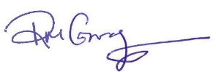
Rachel Gray
Executive Director, Central Valley Salinity Coalition, Administrator of CV-SALTS Nitrate Control Program

Maureen Thompson
Executive Director
Valley Water Collaborative on behalf of the following Management Zones:
Modesto, Turlock, Merced, Delta Mendota, Eastern San Joaquin, Madera, Yolo

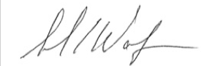
Sarah Wolf
President, Water Wise
Chowchilla Management Zone

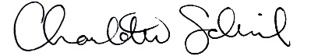
Charlotte Schuil
Water Program Manager, 4Creeks for Kaweah Water Foundation
Kaweah Management Zone

Charlotte Schuil
Water Program Manager, 4Creeks for Tule Basin Water Foundation
Tule Basin Management Zone

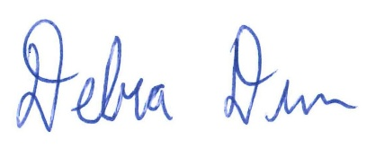
Debra Dunn
Executive Officer, Kings Water Alliance
Kings Management Zone (Kings and Tulare Lake groundwater subbasins)

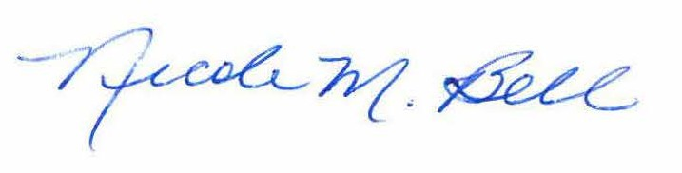
Nicole Bell
Executive Director, Kern Water Collaborative
Kern Poso, Kern Westside South and Kern River Management Zones

